Programs day 3

1.WRITE A PYTHON PROGRAM TO MERGE TWO LISTS?

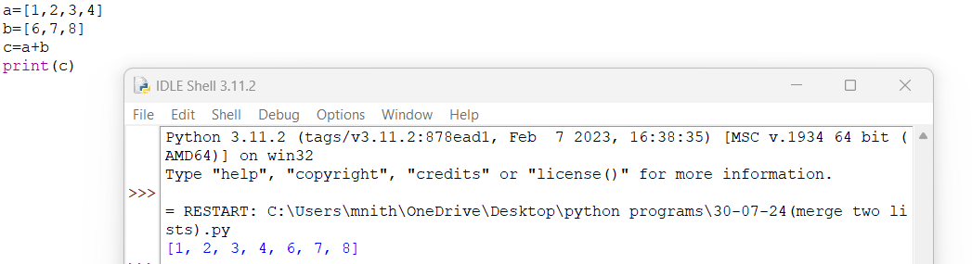

2.WRITE A PYTHON PROGRAM TO COUNT THE NUMBER OF OCCURANCE OF AN ELEMENT?

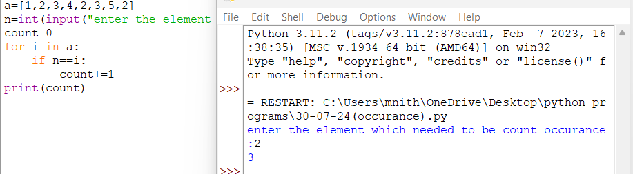

3.WRITE A PYTHON PROGRAM TO INSERT AN ELEMENT IN A LIST?

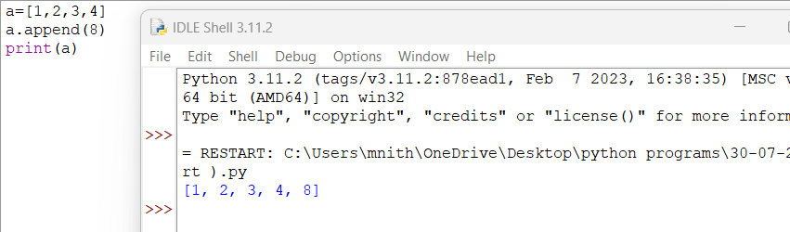

4.WRITE A PYTHON PROGRAM TO FIND INDEX OF AN ELEMENT IN A LIST?

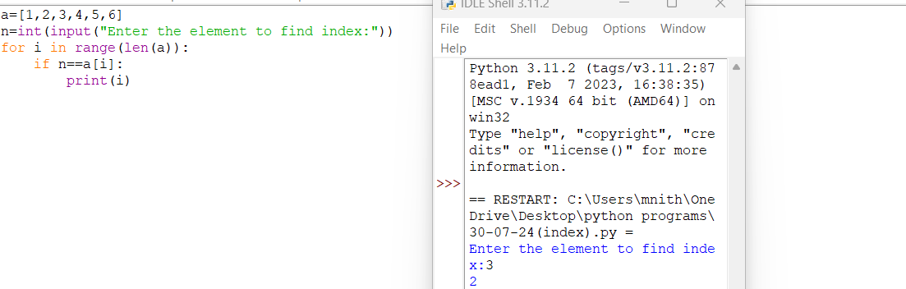

5.WRITE A PYTHON PROGRAM TO FIND ODD AND EVEN ELEMENTS OF A LIST?

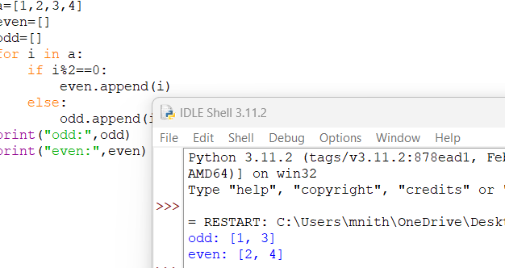

6.WRITE A PYTHON PROGRAM TO FIND DUPLICATE ELEMENTS IN A LIST?

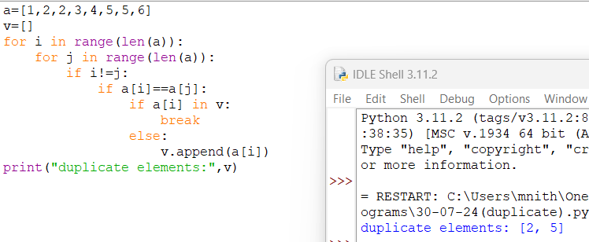

7.WRITE A PYTHON PROGRAM FOR MULTIPLICATION TABLE?

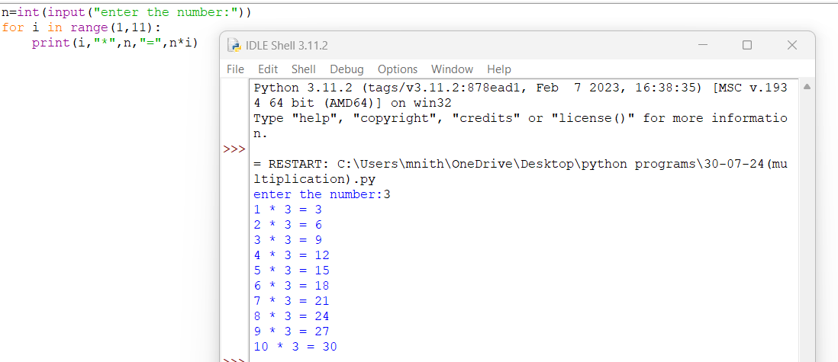

8.WRITE A PYTHON PROGRAM TO CREATE A DICTONARY AND PRINT IT?



9.WRITE A PYTHON PROGRAM TO COUNT THE NO OF VOWELS AND CONSONENTS IN A STRING?

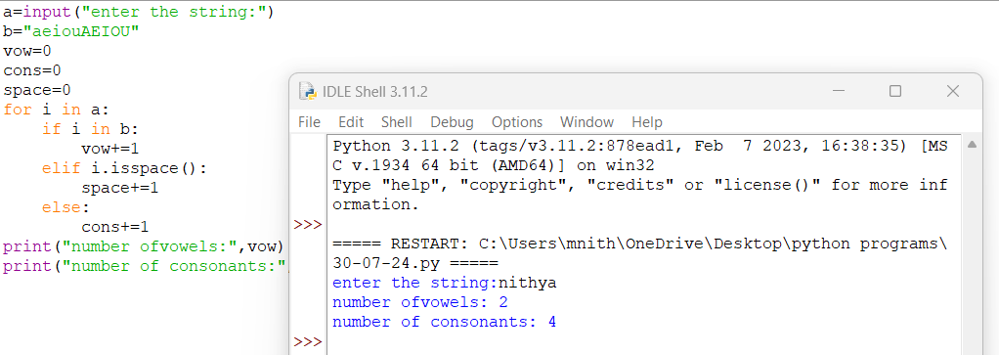10.WRITE A PYTHON PROGRAM TO PERFORM STRING OPERATIONS?

